**ABHISHEK SHARMA**

**CS 2ND YEAR**

**SECTION : "I"**

**ROLL NO.: 01**

**ENROLLMENT NO.: 12019009001127**

**PRE PLACEMENT CLASS**

**ASSIGNMENT**

**DATE : 05.11.2020**

**C Programs Solutions**

**Q1. Problem 1 : Identify the first non-repeating character and the position of the character.**

**Code :**

#include <stdio.h>

#include <stdlib.h>

#define NO_OF_CHARS 256

int* getCharCountArray(char* str)

{

int* count = (int*)calloc(

sizeof(int), NO_OF_CHARS);

int i;

for (i = 0; *(str + i); i++)

count[*(str + i)]++;

return count;

}

int firstNonRepeating(char* str)

{

int* count = getCharCountArray(str);

int index = -1, i;

for (i = 0; *(str + i); i++) {

if (count[*(str + i)] == 1) {

index = i;

break;

}

}

free(count);

return index;

}

int main()

{

char str[100];

printf("Enter the string : ");

scanf ("%s",&str);

int index = firstNonRepeating(str);

if (index == -1)

printf("-1");

else{

printf("First non-repeating character is %c\n", str[index]);

printf ("The index position is %d", index+1);

}

getchar();

return 0;

}

**Output :**

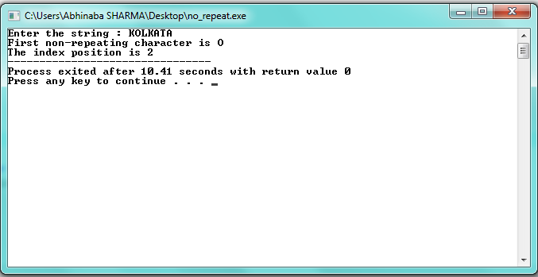

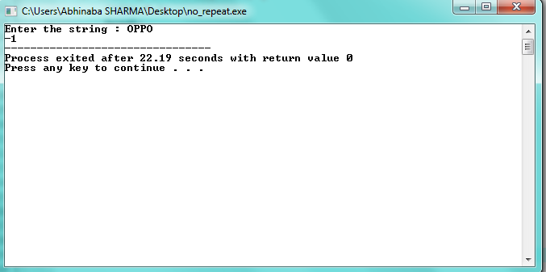

**Q2. Problem 2 : Bob's steps**

**Code :**

#include <stdio.h>

int main(){

int test, n,m, step, extra;

int total;

int i=0;

printf ("Enter the number of the testcases : ");

scanf ("%d",&test);

for (i=0;i<test;i++){

printf ("Enter the value of N : ");

scanf ("%d",&n);

total = 4*n;

m= n+1;

step = total/m;

extra = total%m;

if (extra==0){

printf ("Total no. of moves will be %d\n", step);

}

else if (extra>0){

printf ("Total no. of moves will be %d\n", step+1);

}

}

return 0;

}

**Output :**

